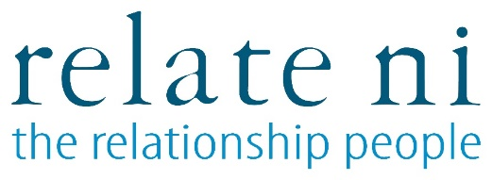

**CONFIDENTIAL Ref: ARC-C/JUNE22**

**MONITORING QUESTIONNAIRE:**

**GUIDANCE NOTES:**

Relate NI is fully committed to Equal Opportunities. We aim to provide equality of opportunity to all persons regardless of their religious belief; political opinion; sex; race; age; sexual orientation; or, whether they are married or are in a civil partnership; or, whether they are disabled.

In this questionnaire we will ask you to provide us with some personal information about yourself. We are doing this to demonstrate our commitment to promoting equality of opportunity. The information that you provide us will assist us to measure the effectiveness of our equal opportunity policies.

Your identity will be kept anonymous and your answers will be treated with the strictest confidence. The information provided will not be made available to those considering your application.

**COMMUNITY BACKGROUND**

Regardless of whether we practice religion, most of us in Northern Ireland are seen as either Protestant or Roman Catholic.

Please indicate the community to which you belong by ticking the appropriate box below:



I am a member of the Protestant community:

I am a member of the Roman Catholic community:

I am not a member of either the Protestant or the Roman Catholic communities:

*If you do not answer the above question, we are encouraged to use a residuary method of making a determination.*

**GENDER**

Please indicate your gender by ticking the appropriate box below:

Male

Female

Other (non-binary or gender neutral)

**AGE:**

Please state your date of birth:

Date of birth: ______________________________

**ETHNIC INFORMATION:**

What is your ethnic group? Choose one option which best describes your ethnic group or background:





White Chinese



Irish Traveller Indian





Pakistani Bangladeshi



Black Caribbean Black African





Black Other



Mixed ethnic group (please write): ­­­­­­­­­­­­­________________________________

Any other ethnic group (please write: ­­­­­­________________________________

**SEXUAL ORIENTATION:**

My sexual orientation is towards:

Persons of a different sex to me:





Persons of the same sex as me:

Persons of both sexes



**DISABILITY:**

Under the *Disability Discrimination Act 1995* a person is deemed to be a disabled person if he or she has a physical or mental impairment which has a substantial and long-term adverse effect on his or her ability to carry out normal day-to-day activities. Please note that it is the effect of the impairment without treatment which determines whether an individual meets this definition.

Do you consider that you are a disabled person?

Yes No





If “yes”, please indicate the nature of your impairment below:

___________________________________________________________________________________

**MARITAL STATUS/CIVIL PARTNERSHIP STATUS:**

Are you married or in a civil partnership?



Yes No



**DEPENDANTS/CARING RESPONSIBILITES:**

Do you have dependants, or caring responsibilities for family members or other persons?

Yes No





Are your dependants or the people your look after? (Please tick the appropriate box or boxes):



A child or children:

A disabled person or persons:



An elderly person or persons:



Other:

If “Other”, please specify:

**Thank you for providing this information**