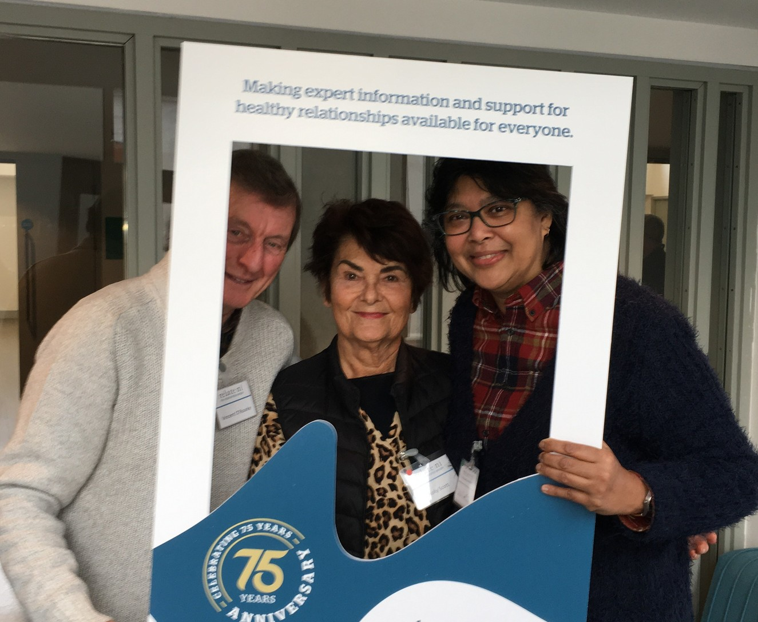
APPLICATION PACK
Referral Administration & Scheduler

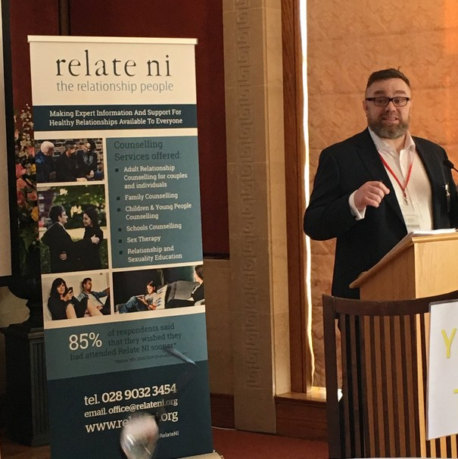

Welcome!
DUANE FARRELL, CEO
Hello and thanks for downloading this recruitment pack and for your interest in the role of [DN insert role title] .

Relate NI is passionate about enabling good quality relationships for our diverse society in Northern Ireland. Through our experience of working with people across Northern Ireland, we’ve come to understand that relationships not only give our lives meaning; they are of vital importance to our wellbeing. In fact, good quality relationships are one of the most important assets we have as a society. Research and evidence now demonstrate why good quality relationships matter. Evidence indicates that good quality relationships are a crucial protective factor which can shield us from the effects of long-term health conditions; aid our recovery and can even prevent illness in the first place.

This is an exciting time to join the team at Relate NI team as we celebrate 75 years of providing high quality support for people and their relationships right across Northern Ireland, and as we look towards the ongoing relationship support needs of people and communities in the years to come.

Here at Relate NI, we understand that our people are the key means through which we suppor

people to improve their lives and relationships around them. That’s why we pay attention to making the organisation a great place to work. We achieve this through our pay and benefits package; through attention to living the organisation’s values; and through the support provided to our team in their day-to-day work. We were delighted recently that this work was recognised when Relate NI was awarded the Investors in People standard.

So please take some time to find out more about Relate NI, the work we do and why you should think about submitting an application to come and join us to make a difference in the lives of people and communities right across Northern Ireland.

We look forward to receiving your application.

Duane Farrell, CEO

ABOUT RELATE NI

Relate NI is a charity with a mission to make expert information and support for healthy relationships available for everyone. Our vision is of a future where healthy relationships are at the heart of a thriving society, and our mission is to make expert information and support for healthy relationships available to everyone. We have a number of ways in which we do this:

- Provision of Therapeutic Services

Our core service and what we are probably best known for is the counselling support we have provided to people across Northern Ireland for more than 75 years. We provide counselling in the community to families, couples, individuals, teenagers and children from our premises in Belfast and Portadown, and through outcentres in Derry-Londonderry, Coleraine and Ballymena. Our counsellors are qualified and have several years’ experience in relationship counselling. Relate NI is registered with the British Association of Counselling and Psychotherapy (BACP) and adhere to its professional standards. We also work with community-based organisations in Belfast to provide counselling and other supports to primary school children through the FSCN, MuMO and STEP programmes and we are also on the Healthy Happy Minds framework for counselling in primary schools across Northern Ireland.

– Provision of Education and Training Programmes

Relate NI has always been an advocate of Relationship and Sexuality Education and works in partnership with Nexus NI and The Rainbow Project to provide this to young people aged 15 and 16 years through a range of host organisations working with young people across Northern Ireland. The programme is supported by the
Public Health Agency. We also deliver a CPCAB Level V Diploma in Relationship Counselling.

– Delivery of Projects

Here at Relate NI, we are always looking for new ways to provide high quality and accessible relationship support to people. The Sustaining Healthy Relationships project is a new and innovative venture which has been supported through the Dormant Accounts Fund. Through this project we want to transform the way we work with and provide support to people by taking our educational interventions into the heart of communities with a view to preventing and or reducing relationship stress through providing tools and techniques to encourage, nurture and strengthen the foundational relationships that bring us joy and improve our mental and physical wellbeing. We provide education interventions to people involved in a range of youth and community groups through this programme.

We also deliver the Golden Threads Programme as we know that healthy relationships are the golden threads that bind our communities together. They are a fundamental cornerstone of our health and mental wellbeing. People who are more socially connected to family, friends, or their community are happier, physically healthier and live longer, with fewer mental health problems than people who are less well connected. With funding from the DoH Mental Health Support Fund through the Community

2021 Good Governance Award Winners
(Medium Size Organisation)

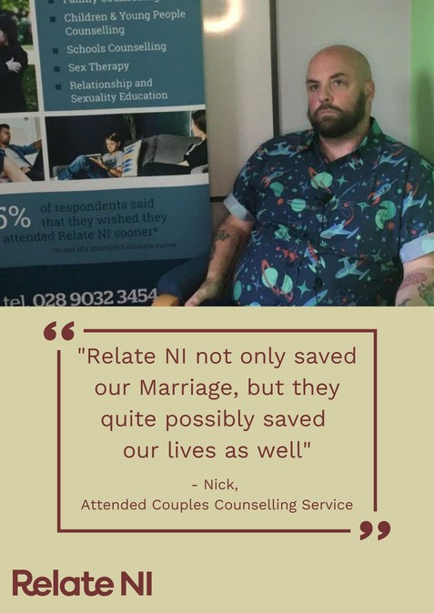
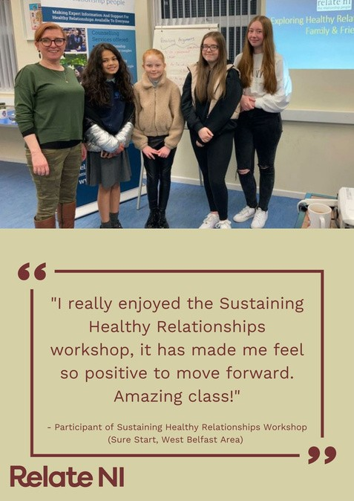
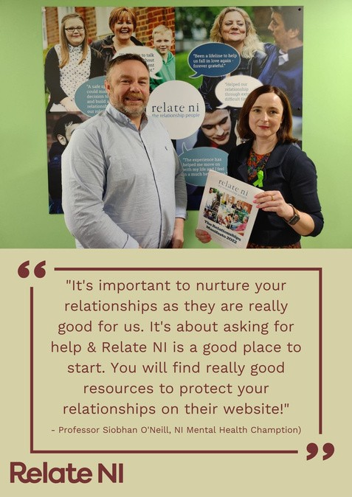
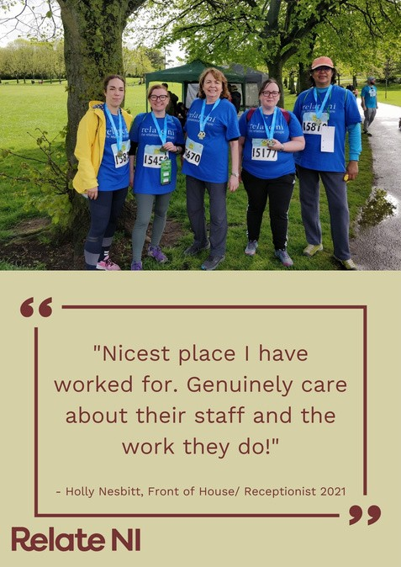
HELP US MAKE A DIFFERENCE IN THE LIVES OF PEOPLE ACROSS NORTHERN IRELAND

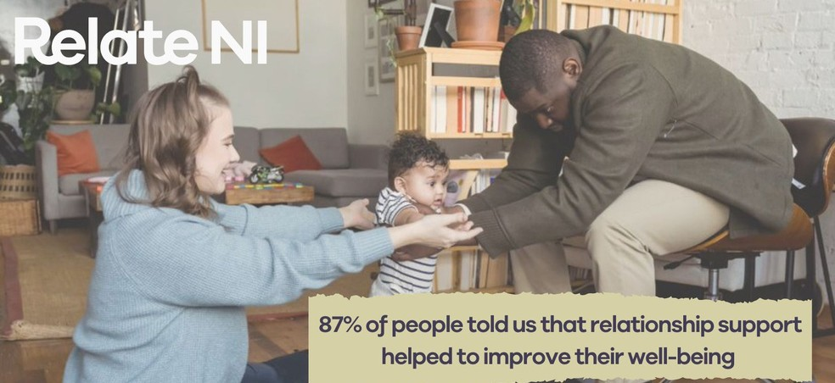
WORKING AT RELATE NI

Relate NI is an accredited Investor in People and to that end we are keen to support our staff through learning and development and continuous professional development opportunities. We provide all our staff with line management support and our counsellors with clinical supervision, both individual and group. Relate NI also provide all mandatory training at no cost to clinical employees.

Relate NI is accredited to provide CPCAB qualifications including a bespoke Level 5 Diploma in Relationship Counselling and can offer subsidised routes for those working with the organisation interested in completing this.

Following our recent re-accreditation for Investors in People here is what some of our staff said about working with Relate NI:

“I get a sense of helping people – doing something for a purpose” “We are trusted to do what we do, professionally and ethically”
“I came to work in Relate NI because I wanted to do something that improves peoples’ lives”
“I was made feel very welcome; a valued member of the team”

“Takes the time to keep you up to date with what is happening and gives me feedback on how I am doing”
“Every year there has been improvement”

“We put relationships at the core of what we do, and that includes working with each other”

RELATE NI PAY & BENEFITS

We continually review our pay and benefits package to make sure that Relate NI offers the best possible experience to our team. The pay and benefits package currently includes:

-[DN insert details on pay for the role] with an annual review from the board of trustees.
-All clinical roles receive access to paid clinical supervision and the option of participating in a monthly Reflexive Supervision Group (RSG)
-Access to support with CPD, both mandatory and discretionary
-Access to a pension scheme with 5% employee contributions matched by 3% employers’ contribution
-25 days (pro-rata) annual leave plus 13 statutory days (pro-rata)
Access to health and wellbeing support through the Health Assured programme

2022 Trustee of the Year Winners (Aidan Bennett, Chair)

REFERRAL ADMINISTRATOR & SCHEDULER

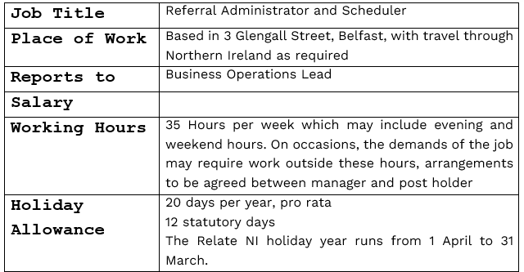

Backg round

Relate NI is the leading relationship support charity in Northern Ireland and has been working to support people and their relationships since 1948. We provide a range of therapeutic services and education programmes to people throughout Northern Ireland. Our vision is of a future where healthy relationships are at the heart of a thriving society, and our mission is to make expert information and support for healthy relationships available to everyone. We are currently recruiting for the post of Referral Administrator and Scheduler.

Overall Job Purpose

Working under the direction of the Head of Business Operations, the role of Referral Administrator and Scheduler is a service user-focused position, which is tasked with assigning relevant professionals to individual requirements. You will provide exemplary customer service within a timely manner and provide an invaluable service to clients calling the business. You will identify areas for improvement and play an integral part within the team.

Clients:

- Providing client & potential clients with information on Relate NI services.
- Dealing with inbound and outbound communications (telephone, webchat and email) promptly and efficiently
- Ensuing that distressed or anxious clients are supported and managed in an appropriate manner
- Taking payments from clients and dealing with outstanding payments

Administration:

- Managing Waiting lists and counsellor caseloads
- Assisting clients by determining needs, scheduling or cancelling appointments or referring to correct staff person
- Arranging of zoom sessions and sending links out to relevant parties
- Producing weekly reports on activity and areas of improvement in relation to agreed KPI’s
- Updating client information on the relevant systems ensuring data protection is adhered to at all times
- Providing administration support and training to the counselling team in using relevant systems
- Providing training as part of the Induction process for new members of staff
- Providing administration support to the Clinical and Business Operations teams
- Providing administration support in relation to student placement activity and appointment allocation
- Maintain and update schedule of counsellor availability; maintains contact with clients, notifying them of any scheduling changes
- To arrange appropriate rooms within out centres to ensure that Counselling can take place
- All other administration duties which may be necessary to ensure the smooth running of the centre

Business Improvement/QA:

- Maintaining accurate records on the Computerised system for all clients
- Sensitively managing any complaints, escalating appropriately to ensure that the company policy is adhered to
- To support the Business Operations team in carrying out any Quality Audits or Business Improvement Initiatives

This job description is neither exhaustive nor exclusive and the post holder will be expected to undertake duties within competence, which are required in line with the overall job purpose. The role profile may be reviewed and amended in the future to include any other reasonable duties, projects or tasks as may be requested from time to time and to reflect changing organisational requirements, strategic or operational priorities, and changing staffing levels.

